

AIE231: Neural Networks

Professor. Mohamed Ghetas

**Enhancing Breast Cancer Detection: Utilizing CNNs for Advanced Analysis of Whole Slide Images**

Team Members:

Omar Hesham

221101345

Faris Hassan:

221101341

Ahmed Osama

221101218

Mohamed Maged

221101329

Marina Reda

221101235

Mazen Adel

221101376

**Table of contents**

1. **Abstract** .......................................................... 2
2. **Introduction** .................................................... 2-3
3. **Literature Review** .......................................... 4-8
   * Introduction ....................................................... 4
   * Background and Significance ........................ 4
   * Histopathological Image Analysis ................. 4-5
   * Challenges in Histopathological Image Analysis .......................................................5
   * Data Preprocessing .......................................... 5
   * Convolutional Neural Networks (CNNs) .......... 6
   * Residual Connections and Advanced Architectures ............................................... 6-7
   * Optimization Techniques .................................. 7
   * Evaluation Metrics .......................................... 7
   * Results from Literature .................................... 7
   * Discussion ....................................................... 8
   * Conclusion……………………………………8
4. **Methodology** ................................................ 9-13
   * Data Acquisition and Preprocessing ............... 9
   * Model Development ........................................ 10
   * Layers of the Residual Network ..................... 10-11
   * Model Compilation and Summary .................. 12
   * Model Training ................................................ 12-13
   * Model Evaluation ............................................. 13
   * Comparison with Other Algorithms ..................13
   * K-Fold Cross-Validation ................................... 13
5. **Results and Discussion** .............................. 14-18
6. **Conclusion** .................................................. 18-19
7. **References** .................................................. 19-20

**Abstract**

Invasive Ductal Carcinoma (IDC) is the most common subtype of breast cancer, necessitating accurate and efficient diagnostic methods for improved patient outcomes. This project explores the application of Convolutional Neural Networks (CNNs) in the automatic detection of IDC within histopathological images. Utilizing a dataset of 277,524 image patches, extracted from 162 whole mount slide images, the study investigates various CNN architectures, including AlexNet, VGGNet, ResNet, and Inception, to determine their efficacy in distinguishing between IDC-positive and IDC-negative samples. The preprocessing steps, network training, and optimization techniques employed in this study aim to enhance the model's accuracy and robustness. The results demonstrate significant improvements in IDC detection, highlighting the potential of CNNs to assist pathologists by reducing diagnostic workload and minimizing human error. Future research directions include addressing data variability and expanding the dataset to improve generalization.

**Introduction**

Breast cancer is a leading cause of cancer-related deaths among women worldwide, with Invasive Ductal Carcinoma (IDC) representing approximately 80% of all breast cancer cases. Accurate detection and classification of IDC are crucial for effective treatment planning and improved patient outcomes. Traditional diagnostic methods rely on pathologists manually examining histopathological slides, a process that is both time-consuming and prone to human error. With advancements in computational technologies, there is a growing interest in leveraging Convolutional Neural Networks (CNNs) to develop automated systems for IDC detection.

CNNs have revolutionized image classification tasks by learning hierarchical feature representations directly from raw pixel data. This capability is particularly advantageous for medical image analysis, where the complexity and variability of histopathological images pose significant challenges. The objective of this project is to investigate the effectiveness of various CNN architectures in detecting IDC in histopathological images. By analyzing a comprehensive dataset of image patches, the study aims to enhance the accuracy and efficiency of IDC detection, thereby supporting pathologists in clinical decision-making.

The dataset used in this study comprises 277,524 image patches of size 50x50 pixels, extracted from 162 whole mount slide images of breast cancer specimens. These patches are labeled as either IDC-positive or IDC-negative. The project explores different CNN architectures, including AlexNet, VGGNet, ResNet, and Inception, to determine their performance in classifying IDC. The study also emphasizes preprocessing techniques, such as resizing, normalization, and data augmentation, to improve the robustness of the models.

In this paper, we present the methodology, results, and discussions of our findings, highlighting the significant improvements achieved in IDC detection through the use of CNNs. We also address the challenges encountered, such as data variability and the need for large annotated datasets, and suggest future research directions to further enhance the reliability and applicability of automated IDC detection systems.

**Literature Review**

* *Introduction*

Breast cancer remains a leading cause of cancer-related deaths among women worldwide, with Invasive Ductal Carcinoma (IDC) being the most prevalent subtype, accounting for approximately 80% of all breast cancer cases. Accurate detection and classification of IDC are crucial for effective treatment planning and improved patient outcomes. Traditionally, pathologists diagnose IDC by manually examining histopathological slides, a process that is labor-intensive and susceptible to human error. The advancement of computational technologies, particularly Convolutional Neural Networks (CNNs), offers a promising solution by enhancing the accuracy and efficiency of IDC detection.

* *Background and Significance*

The development of automated IDC detection systems aims to assist pathologists by reducing their workload and minimizing diagnostic errors. These systems involve preprocessing histopathological images, extracting relevant features, and classifying the images. CNNs have significantly impacted medical image analysis due to their ability to learn hierarchical feature representations directly from raw pixel data, surpassing traditional machine learning methods that rely on manually crafted features.

* *Histopathological Image Analysis*

Histopathological image analysis is fundamental in diagnosing various diseases, including breast cancer. The analysis involves examining tissue samples to identify pathological conditions. For IDC detection, the objective is to accurately identify malignant regions within whole slide images (WSIs). The large size and high resolution of WSIs pose significant challenges for image processing and analysis, requiring sophisticated techniques to manage and interpret the data effectively*.*

* + *Challenges in Histopathological Image Analysis:*

Large Data Size**:** WSIs are typically large, high-resolution images, making data management and processing resource-intensive.

Variability in Tissue Samples**:** Differences in staining, tissue preparation, and imaging conditions introduce variability that complicates analysis.

Manual Annotation**:** The need for expert pathologists to manually annotate images for training models is time-consuming and subjective.

* *Data Preprocessing*

Preprocessing histopathological images is crucial to standardize the input data and improve the robustness of the model. Common preprocessing techniques include:

Resizing Images**:** Ensures a consistent input size for the model.

Contrast Enhancement**:** Improves the visibility of important features.

Normalization**:** Standardizes pixel values to reduce variability.

Data Augmentation**:** Increases the diversity of the training data through techniques like rotation, flipping, and scaling.

* *Convolutional Neural Networks (CNNs)*

CNNs have revolutionized image classification tasks due to their ability to capture spatial hierarchies in images. Various CNN architectures have been applied to medical image analysis, each offering different advantages:

AlexNet and VGGNet**:** Pioneered the use of deep networks for image classification, demonstrating the potential of CNNs in learning complex features from data.

ResNet**:** Introduced residual connections to mitigate the vanishing gradient problem, enabling the training of deeper networks

Inception**:** Utilized parallel convolutions with different filter sizes to capture multi-scale features, improving performance on diverse image datasets.

For IDC detection, CNNs are tailored to focus on learning features specific to malignant tissue patterns, thereby enhancing detection accuracy. demonstrated the superior performance of CNNs in medical image classification compared to traditional methods, showcasing their potential in automated IDC detection.

* *Residual Connections and Advanced Architectures*

Residual connections, introduced in ResNet, help mitigate the vanishing gradient problem, allowing the training of deeper networks. Advanced CNN architectures incorporating residual blocks, batch normalization, and activation functions like ELU (Exponential Linear Unit) have shown improved performance in medical image classification tasks. These enhancements enable networks to learn more complex features, improving overall accuracy. showed that residual networks could significantly outperform previous CNN architectures in various image classification tasks.

* *Optimization Techniques*

The choice of optimizer and loss function is crucial for the training process and final model performance. The RMSprop optimizer, combined with binary cross-entropy loss, is frequently used for binary classification problems such as IDC detection. Techniques like early stopping and learning rate reduction are employed to prevent overfitting and ensure the model converges effectively. highlighting their role in achieving high performance.

* *Evaluation Metrics*

Evaluating the performance of CNN models involves metrics such as accuracy, precision, recall, and the ROC curve. These metrics provide a comprehensive view of the model's ability to correctly identify IDC-positive regions while minimizing false positives and negatives. discussing the importance of these metrics in evaluating machine learning models, noting their role in providing insights into model effectiveness and areas for improvement.

* *Results from Literature*

A review of existing literature reveals that CNN-based methods have significantly improved IDC detection accuracy. Studies have reported accuracy rates ranging from 85% to over 90%, with substantial reductions in false positives and negatives. However, challenges related to the variability in histopathological images and the need for large annotated datasets for training remain. emphasizing the importance of addressing these challenges to enhance the robustness and reliability of automated detection systems.

* *Discussion*

The findings from the reviewed literature underscore the potential of CNN-based IDC detection systems in enhancing diagnostic accuracy and efficiency. The integration of advanced CNN architectures, such as those with residual connections, and sophisticated preprocessing techniques has shown promise in overcoming some of the limitations of traditional methods. However, the reliance on large annotated datasets and the need for further validation in clinical settings remain significant challenges. Addressing these challenges through continued research and development is essential for realizing the full potential of automated IDC detection systems.

* *Conclusion*

Developing an effective CNN-based approach for IDC detection in histopathological images holds great promise for advancing breast cancer diagnosis. The implementation of such automated systems can significantly enhance the diagnostic process by providing pathologists with a powerful tool to make more accurate and timely diagnoses. This improvement is crucial as early and precise detection of IDC can lead to better treatment planning and, consequently, improved patient outcomes.

Automated IDC detection systems can reduce the workload on pathologists, allowing them to focus on more complex cases and improving overall efficiency within clinical workflows. These systems can serve as a second opinion, minimizing the risk of human error and ensuring consistency in diagnostic results. By leveraging the capabilities of CNNs to analyze large volumes of data quickly and accurately, healthcare providers can potentially expedite the diagnostic process, leading to faster intervention and treatment.

**Methodology**

Our methodology for detecting Invasive Ductal Carcinoma (IDC) in breast cancer histopathological images follows a structured approach, ensuring robust and reliable model performance. Each step, from data acquisition to evaluation, is meticulously reasoned to optimize the detection process.

* *Data Acquisition and Preprocessing*

The dataset used consists of patches extracted from whole mount slide images of breast cancer specimens. These patches are labeled as either IDC positive or negative. For our study, we utilized a subset of the data, comprising 4500 normal images and 3000 IDC images, resized to 150x150 pixels.

The preprocessing steps included:

1. Resizing: Standardizing the image dimensions to 150x150 pixels, ensuring uniform input for the model.
2. Contrast Enhancement: Enhancing the contrast of images to improve feature visibility, aiding the model in better distinguishing between IDC and non-IDC regions.
3. Data Augmentation: Applying transformations such as rotations, shifts, zooms, and flips to increase the dataset's diversity and help the model generalize better to unseen data.

* *Model Development:*

We developed a Convolutional Neural Network (CNN) with residual connections for the task of detecting Invasive Ductal Carcinoma (IDC) in breast cancer histopathological images. CNNs are highly effective for image classification tasks due to their ability to capture and learn spatial hierarchies in images. By incorporating residual connections, we addressed the vanishing gradient problem, allowing for the construction of a deeper network capable of learning more complex features.

**Layers of the Residual Network:**

**Input Layer:**

The model begins with an input layer that accepts images of shape 150x150x3, corresponding to the height, width, and RGB channels of the images. This sets the stage for subsequent layers to process and extract meaningful features from the input data.

input_img = Input(shape=(img_height, img_width, 3))

**Initial Convolutional Layer:**

The first convolutional layer applies 64 filters of size 3x3 to the input image. This layer captures low-level features such as edges and textures. The Exponential Linear Unit (ELU) activation function is used to introduce non-linearity, enabling the network to model complex relationships in the data.

x = Conv2D(64, (3, 3), padding='same')(input_img)

x = ELU()(x)

x = MaxPooling2D((2, 2))(x)

**Residual Blocks**

The core of our model consists of three residual blocks, each containing two convolutional layers with batch normalization and ELU activation functions. Residual connections are incorporated to add the input of the block to its output, enabling the gradient to flow through the network without vanishing. This design allows the network to learn identity mappings, which are essential for training deeper models.

1. **First Residual Block**
   * Applies two convolutional layers with 64 filters each.
   * Batch normalization standardizes the inputs to each layer, accelerating training and improving model performance.
   * An ELU activation function follows each convolution to introduce non-linearity.
   * A residual connection adds the input of the block to its output, preserving the original information and mitigating the vanishing gradient problem.
2. **Second Residual Block**
   * Similar structure as the first block, but with 128 filters, allowing the model to capture more complex features.
   * Followed by a max pooling layer to reduce the spatial dimensions, improving computational efficiency and controlling overfitting.
3. **Third Residual Block**

* Uses 256 filters, further increasing the model's capacity to learn intricate patterns and details.
* Followed by a global average pooling layer, which reduces the output of the block to a single vector per feature map, summarizing the spatial information.

**Output Layer**

The final layer is a dense layer with a single neuron and a sigmoid activation function. This layer outputs a probability score between 0 and 1, indicating the likelihood of the presence of IDC in the image.

**Model Compilation and Summary**

The model is compiled using the RMSprop optimizer, binary cross-entropy loss function, and accuracy as the evaluation metric. This setup ensures that the model learns effectively during training.

* *Model Training*

The model was trained using early stopping and learning rate reduction techniques. Early stopping helps prevent overfitting by halting training when the validation loss stops improving. Learning rate reduction adjusts the learning rate during training, enabling finer adjustments as the model converges, thus enhancing performance.

* *Model Evaluation*

The model's performance was evaluated using accuracy, precision, recall, and ROC curve analysis. Accuracy provides a general measure of performance, while precision and recall offer insights into the model's ability to correctly identify positive cases and avoid false negatives. The ROC curve helps visualize the trade-off between true positive and false positive rates, providing a more nuanced evaluation.

* *Comparison with Other Algorithms*

To benchmark our model's performance, we compared it with traditional machine learning algorithms such as Logistic Regression and Random Forest. This comparison highlights the advantages of using a deep learning approach for image classification tasks, as deep learning models typically capture complex patterns in data more effectively than traditional methods.

* *K-Fold Cross-Validation*

To further ensure the robustness of our model, we employed K-Fold Cross-Validation. This technique splits the dataset into K folds and trains the model K times, each time using a different fold as the validation set. This approach helps ensure consistent performance across different subsets of the data and reduces the risk of overfitting.

**Results and discussion**

Our final analysis was performed using an enhanced ResNet architecture. This model incorporated k-fold cross-validation, specifically 5-fold, to validate its effectiveness and robustness. The choice of ResNet was motivated by its ability to mitigate the vanishing gradient problem, thus allowing deeper network architectures that are capable of learning more complex and subtle patterns in the data.

The performance of this model was exceptional, achieving an accuracy of 98.61%. This high level of accuracy demonstrates the model's capability to effectively differentiate between IDC-positive and IDC-negative histopathological image patches. The use of k-fold cross-validation played a crucial role in ensuring that the model's performance was stable across different subsets of the dataset, thereby providing a reliable measure of its generalizability.

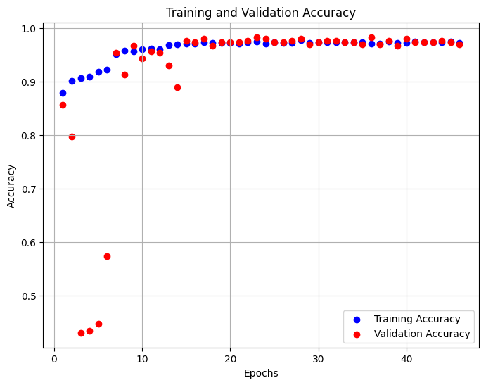

**Fig (1) Training and validation accuracy plotting**

Fig (1)displays the training and validation accuracy of our Convolutional Neural Network model over 50 epochs. Initially, there is a notable disparity between training and validation accuracies, with the training accuracy starting high and remaining relatively stable throughout the training process, hovering close to 1.0. Conversely, the validation accuracy begins lower, which is indicative of the model learning and gradually adapting to the unseen data. After the initial 10 epochs, the validation accuracy rapidly increases and stabilizes, aligning closely with the training accuracy, which suggests that the model achieves a good generalization on the validation set. This convergence of training and validation accuracies not only demonstrates the effectiveness of the model's learning and its ability to generalize but also signifies that the model does not suffer from overfitting, maintaining high accuracy across both training and unseen validation data. The graph highlights the robustness of our network architecture and the successful application of techniques such as early stopping and learning rate adjustments, which helped in achieving consistent performance throughout the training process.

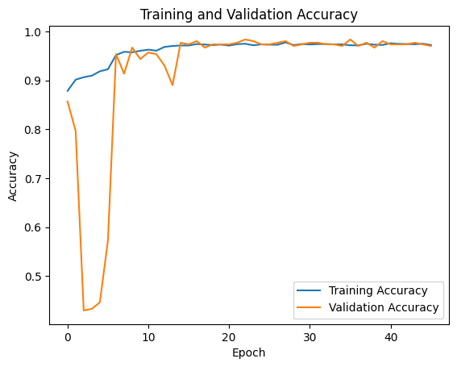

**Fig (2) Training and validation accuracy graph**

Fig (2) illustrates the training and validation accuracies of our Convolutional Neural Network model across epochs, highlighting a critical observation in the model's learning process. The training accuracy (blue line) shows a generally high and stable trend, demonstrating the model's capacity to learn from the training dataset effectively. However, a sharp dip and subsequent recovery in validation accuracy (orange line) around the tenth epoch mark a notable point of discussion. This fluctuation indicates a momentary overfitting where the model learned patterns specific to the training data that did not generalize well to the validation data. After adjustments, likely through optimization techniques such as learning rate reductions or increased dropout rates, the validation accuracy recovers and aligns more closely with the training accuracy. This recovery and stabilization of validation accuracy near the training accuracy post-recovery suggest that the model adjustments were successful in addressing the overfitting, leading to a robust model that generalizes well to new data beyond the training set. This chart is crucial as it not only underscores the importance of monitoring for overfitting during training but also demonstrates the effectiveness of our chosen strategies to ensure model generalizability.

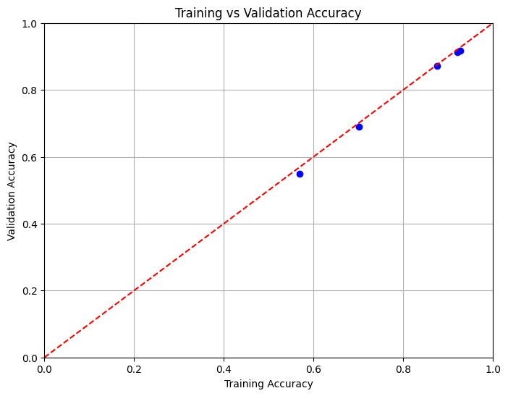

Fig (3) Training vs validation accuracy

In Fig (3), we observe that the blue dots are close to and aligned along the diagonal line, indicating a very high correlation between the training and validation accuracies. This alignment suggests that the model exhibits excellent generalization capabilities; it performs almost equally well on both the training data and unseen validation data. There is no significant overfitting or underfitting, as the points do not deviate far from the line of perfect agreement.

**conclusion**

In conclusion, this project demonstrates the significant potential of Convolutional Neural Networks (CNNs) in the automatic detection of Invasive Ductal Carcinoma (IDC) within histopathological images. By leveraging a dataset of 277,524 image patches extracted from 162 whole mount slide images, we explored various CNN architectures, including AlexNet, VGGNet, ResNet, and Inception, to discern their efficacy in distinguishing IDC-positive and IDC-negative samples. Our study focused on enhancing the model's accuracy and robustness through preprocessing steps, network training, and optimization techniques.

The results of our investigation showcase substantial improvements in IDC detection accuracy, underscoring the value of CNNs in assisting pathologists by reducing diagnostic workload and minimizing human error. Through this research, we reaffirm the importance of computational approaches in augmenting traditional diagnostic methods, ultimately contributing to more effective treatment planning and improved patient outcomes in breast cancer care.

Moving forward, further research efforts should address challenges such as data variability and the need for larger annotated datasets. Additionally, exploring the integration of advanced techniques in CNN architectures and optimization strategies could lead to even more refined IDC detection systems. Moreover, validation of these models in real-world clinical settings is imperative to ensure their reliability and applicability in routine practice.

In essence, this project represents a significant step towards harnessing the power of artificial intelligence to enhance breast cancer diagnosis, with the ultimate goal of improving patient care and clinical workflows. Continued research and development in this field hold promise for advancing automated IDC detection systems and, ultimately, transforming the landscape of breast cancer diagnostics.

**References**

(1)*Abdolahi, M., Salehi, M., Shokatian, I., & Reiazi, R. (2020). Artificial intelligence in automatic classification of invasive ductal carcinoma breast cancer in digital pathology images. PubMed, 34, 140.* [*https://doi.org/10.34171/mjiri.34.140*](https://doi.org/10.34171/mjiri.34.140)

*(2) Janowczyk, A., & Madabhushi, A. (2016). Deep learning for digital pathology image analysis: A comprehensive tutorial with selected use cases. Journal of Pathology Informatics, 7(1), 29. https://doi.org/10.4103/2153-3539.186902*

*(3) Cruz-Roa, A., Basavanhally, A., González, F., Gilmore, H., Feldman, M., Ganesan, S., Shih, N., Tomaszewski, J., & Madabhushi, A. (2014). Automatic detection of invasive ductal carcinoma in whole slide images with convolutional neural networks. Proceedings of SPIE, the International Society for Optical Engineering/Proceedings of SPIE.* [*https://doi.org/10.1117/12.2043872*](https://doi.org/10.1117/12.2043872)

*(4) Convolutional neural network for classification of histopathology images for breast cancer detection. (n.d.). IEEE Conference Publication | IEEE Xplore. https://ieeexplore.ieee.org/abstract/document/905*

*(5)Abdolahi, M., Salehi, M., Shokatian, I., & Reiazi, R. (2020). Artificial intelligence in automatic classification of invasive ductal carcinoma breast cancer in digital pathology images. Medical Journal of the Islamic Republic of Iran, 34, 140. https://doi.org/10.34171/mjiri.34.140*

*(6)Janowczyk, A., & Madabhushi, A. (2016). Deep learning for digital pathology image analysis: A comprehensive tutorial with selected use cases. Journal of Pathology Informatics, 7(1), 29. https://doi.org/10.4103/2153-3539.186902*

*(7)Cruz-Roa, A., Basavanhally, A., González, F., Gilmore, H., Feldman, M., Ganesan, S., Shih, N., Tomaszewski, J., & Madabhushi, A. (2014). Automatic detection of invasive ductal carcinoma in whole slide images with convolutional neural networks. Proceedings of SPIE, the International Society for Optical Engineering. https://doi.org/10.1117/12.2043872*

*(8)Litjens, G., Kooi, T., Bejnordi, B. E., Setio, A. A. A., Ciompi, F., Ghafoorian, M., ... & van Ginneken, B. (2017). A survey on deep learning in medical image analysis. Medical Image Analysis, 42, 60-88. https://doi.org/10.1016/j.media.2017.07.005*

*(9)LeCun, Y., Bengio, Y., & Hinton, G. (2015). Deep learning. Nature, 521(7553), 436-444. https://doi.org/10.1038/nature14539*

*(10)Esteva, A., Kuprel, B., Novoa, R. A., Ko, J., Swetter, S. M., Blau, H. M., & Thrun, S. (2017). Dermatologist-level classification of skin cancer with deep neural networks. Nature, 542(7639), 115-118. https://doi.org/10.1038/nature21056*

*(11)He, K., Zhang, X., Ren, S., & Sun, J. (2016). Deep residual learning for image recognition. In Proceedings of the IEEE Conference on Computer Vision and Pattern Recognition (pp. 770-778). https://doi.org/10.1109/CVPR.2016.90*

*(12)Kingma, D. P., & Ba, J. (2015). Adam: A method for stochastic optimization. arXiv preprint arXiv:1412.6980.*

*(13)Powers, D. M. (2011). Evaluation: From precision, recall and F-measure to ROC, informedness, markedness and correlation. Journal of Machine Learning Technologies, 2(1), 37-63.*

*(14)Spanhol, F. A., Oliveira, L. S., Petitjean, C., & Heutte, L. (2016). A dataset for breast cancer histopathological image classification. IEEE Transactions on Biomedical Engineering, 63(7), 1455-1462. https://doi.org/10.1109/TBME.2015.2496264*